The Slooper Monument Project

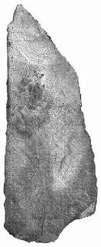
What do you do with a ton and a half stone sent to you by a well-meaning friend from his farm in Norway? This is a happy problem faced these days by Keith Wheeler of the Fram #13 lodge in Eureka whose ancestors once owned this farm. The stone is too big for stone soup, but just right for a bautastein, and this is the reason Einar Slogvik crated up and shipped the huge, nine-foot stone from Norway to California.
Long interested in Norwegian-American immigration history, the Wheelers developed a close friendship with Einar and Rotraud Slogvik, the family currently living on the ancestral farm in Tysvær kommune, north of Stavanger, Rogaland, in Norway. On a Christmas visit to Norway in 2001, the topic first came up of how to properly honor the memory and achievements of Jacob Slogvik who had been born and raised on the Slogvik farm.
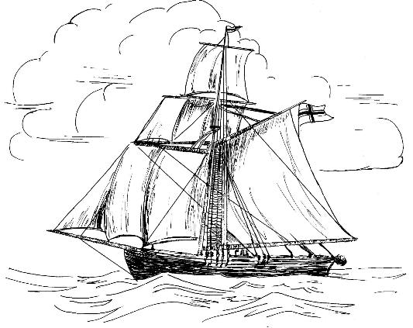
Jacob’s story is part of America’s story. In 1825 at age 18, he and a few others wished to practice Quakerism but were not allowed to do so in Lutheran Norway. Consequently, they participated in the first organized emigration group to leave Norway for America since Viking times. On July 4, 1825, 52 persons sailed aboard a 54-foot sloop called the Restauration and arrived after 96 long, difficult days in New York. This small ship is often called “the Norwegian Mayflower,” although one quarter the size, it was 2.5 times as crowded.
Their life in the new country is also the stuff of legend. Despite struggle, disease, poverty and hardship, the pioneer spirit of Jacob and the other slooperfolk and their descendents is what has made America great. The story of the Sloopers and their progeny is interesting and well documented, thanks to several dedicated historians.
It goes a little like this: Jacob, taking the Americanized name of Jacob Anderson, married Serena Tormodsdatter Madland (also a passenger on the Sloop Restauration) in upstate New York. Jacob moved the family west in the 1830’s to be one of the first families to settle in the historically significant Fox River Settlement of Illinois. In 1848 they moved farther west to southwestern Iowa where they had a large fertile farm. In 1854 the family moved west again, settling just south of the town of Napa in northern California. Here Jacob developed a new farm and lived with his family until his death in 1864. He was buried in the Tulocay Cemetery in the town of Napa. Serine was also buried there in 1898.
In his 1961 book, The Sloopers, J. Hart Rosdail noted “Jacob died farther from his native Norway than any other who came over on the sloop.”
The Slogvik bautastein (or monument stone) is currently at the Turlock Marble and Granite Works, owned by a Norwegian-American family. There it will be engraved, sculpted with an image of the sloop and readied for placement at the large and attractive Napa Tulocay Cemetery. It will be on display at San Francisco’s Norway Day Festival May 8th and 9th.
The dedication ceremony will be held on Saturday, May 15, 2004, at the cemetery, following pageantry, folk dancing and a procession from a nearby park. A banquet with more pageantry and entertainment will be held that evening at the Napa Elks Lodge. This will include a concert by a very special guest from Norway, singing star Hanne Krogh!
Over 20 Norwegians are planning a trip from Norway to California for the event. In anticipation, Keith and his wife, Peg, are scheduling presentations to various Sons of Norway lodges and historical societies to educate and inform people of this opportunity to pay tribute to these pioneers. Keith has prepared a rather extensive website which can be accessed via their family web site at: http://www.wheelerfolk.org
In addition to the Turlock monument company, this project has received support from the Norwegian Consulate General as well as a grant from the Sons of Norway Foundation. The Wheelers would like to express their thanks to those northern California Sons of Norway Lodges that have offered their support. A sincere invitation is extended to other lodges and interested individuals to join this festive and historical occasion in Napa on the May 15th. This can be a combined day of commemorating this interesting part of Norwegian-American immigration history and an early celebration of Syttende Mai!

