The Norwegian Consulate General of San Francisco has agreed to sponsor the appearance of singer Hanne Krogh at the banquet planned as the culmination of the Slooper Monument Project on May 15th 2004 in Napa, California. Hanne hails from Haugesund, the region from which the stone was sent and she has often performed at immigration festivals throughout Norway and US. She is a lovely, delightful and personable entertainer. She sings comfortably in either English or Norsk. Her experience and repertoire of emigration songs will lend a perfect touch to the theme of the celebration.
Popular Norwegian Singer to appear at Slooper Banquet

The Slooper Monument Project Banquet/Concert is to be held at the Napa Elks Hall, 2840 Soscol Ave. at the north end of Napa. Reservations are required and can be purchased from Fram #13 member, Keith Wheeler. Phone 707-574-6595 or e-mail okwheeler@saber.net for information. The menu will include a choice of chicken or beef entrée. Details of the evening’s agenda follow:
5:00: get acquainted, meet old and new friends. No-host bar and soft drinks
6:00: Buffet banquet—chicken ($38) or beef ($40)
7:00: Welcome messages, door prizes and drawings, announcements and thanks.
8:00 popular Norwegian singing star Hanne Krogh Concert !!

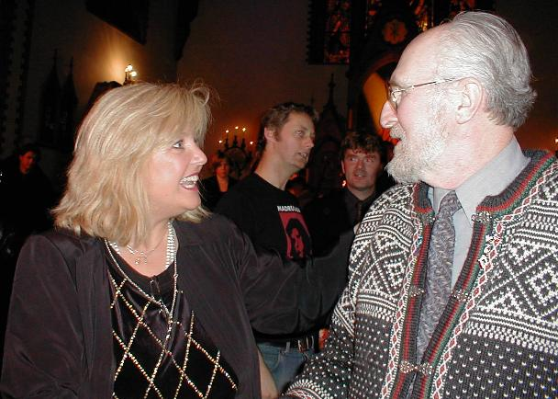

Left above: Peg is pictured with singer, Hanne Krogh aboard the restored coastal steamer, Gamle Rogaland following the emigration festival in Stavanger in July 2000. Keith and Hanne, above right, share a few words after her Christmas concert in Haugesund in 2001

For more information, go to: www.wheelerfolk.org and click on “Slooper Monument Project.

