Rock Project Progresses

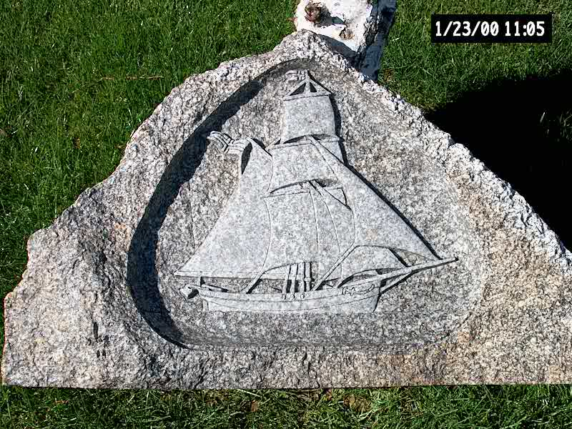
The Slooper “Ship and Stone” project of Fram #13 members, Keith and Peg Wheeler is progressing well according to the Wheelers. The 9-foot ton and a half stone sent from the Slogvik farm in Norway is currently in the hands of stone carver Ira Kessey at Turlock Marble and Granite Works. Kessey is sculpting an image of the famous sloop, Restauration, which brought the first boatload since Viking times of Norwegian immigrants to America in 1825. This led ultimately to the flood of immigrants in subsequent years. Kessey’s “mock-up” or practice piece is pictured here. This piece of historic art will be raffled at the celebration banquet in May in Napa to help with some of the costs of the monumental project. (pun intended)

The current plan is to display the completed stone at the Norway Days Festival in San Francisco on May 8th and 9th, 2004. This “mock-up” piece will also be on display at Kessey’s Festival booth, along with informational materials explaining details of the Slooper Monument Project. Dedication of the stone in Napa is set for Saturday, May 15th.

For more information, go to: www.wheelerfolk.org and click on “Slooper Monument Project.

